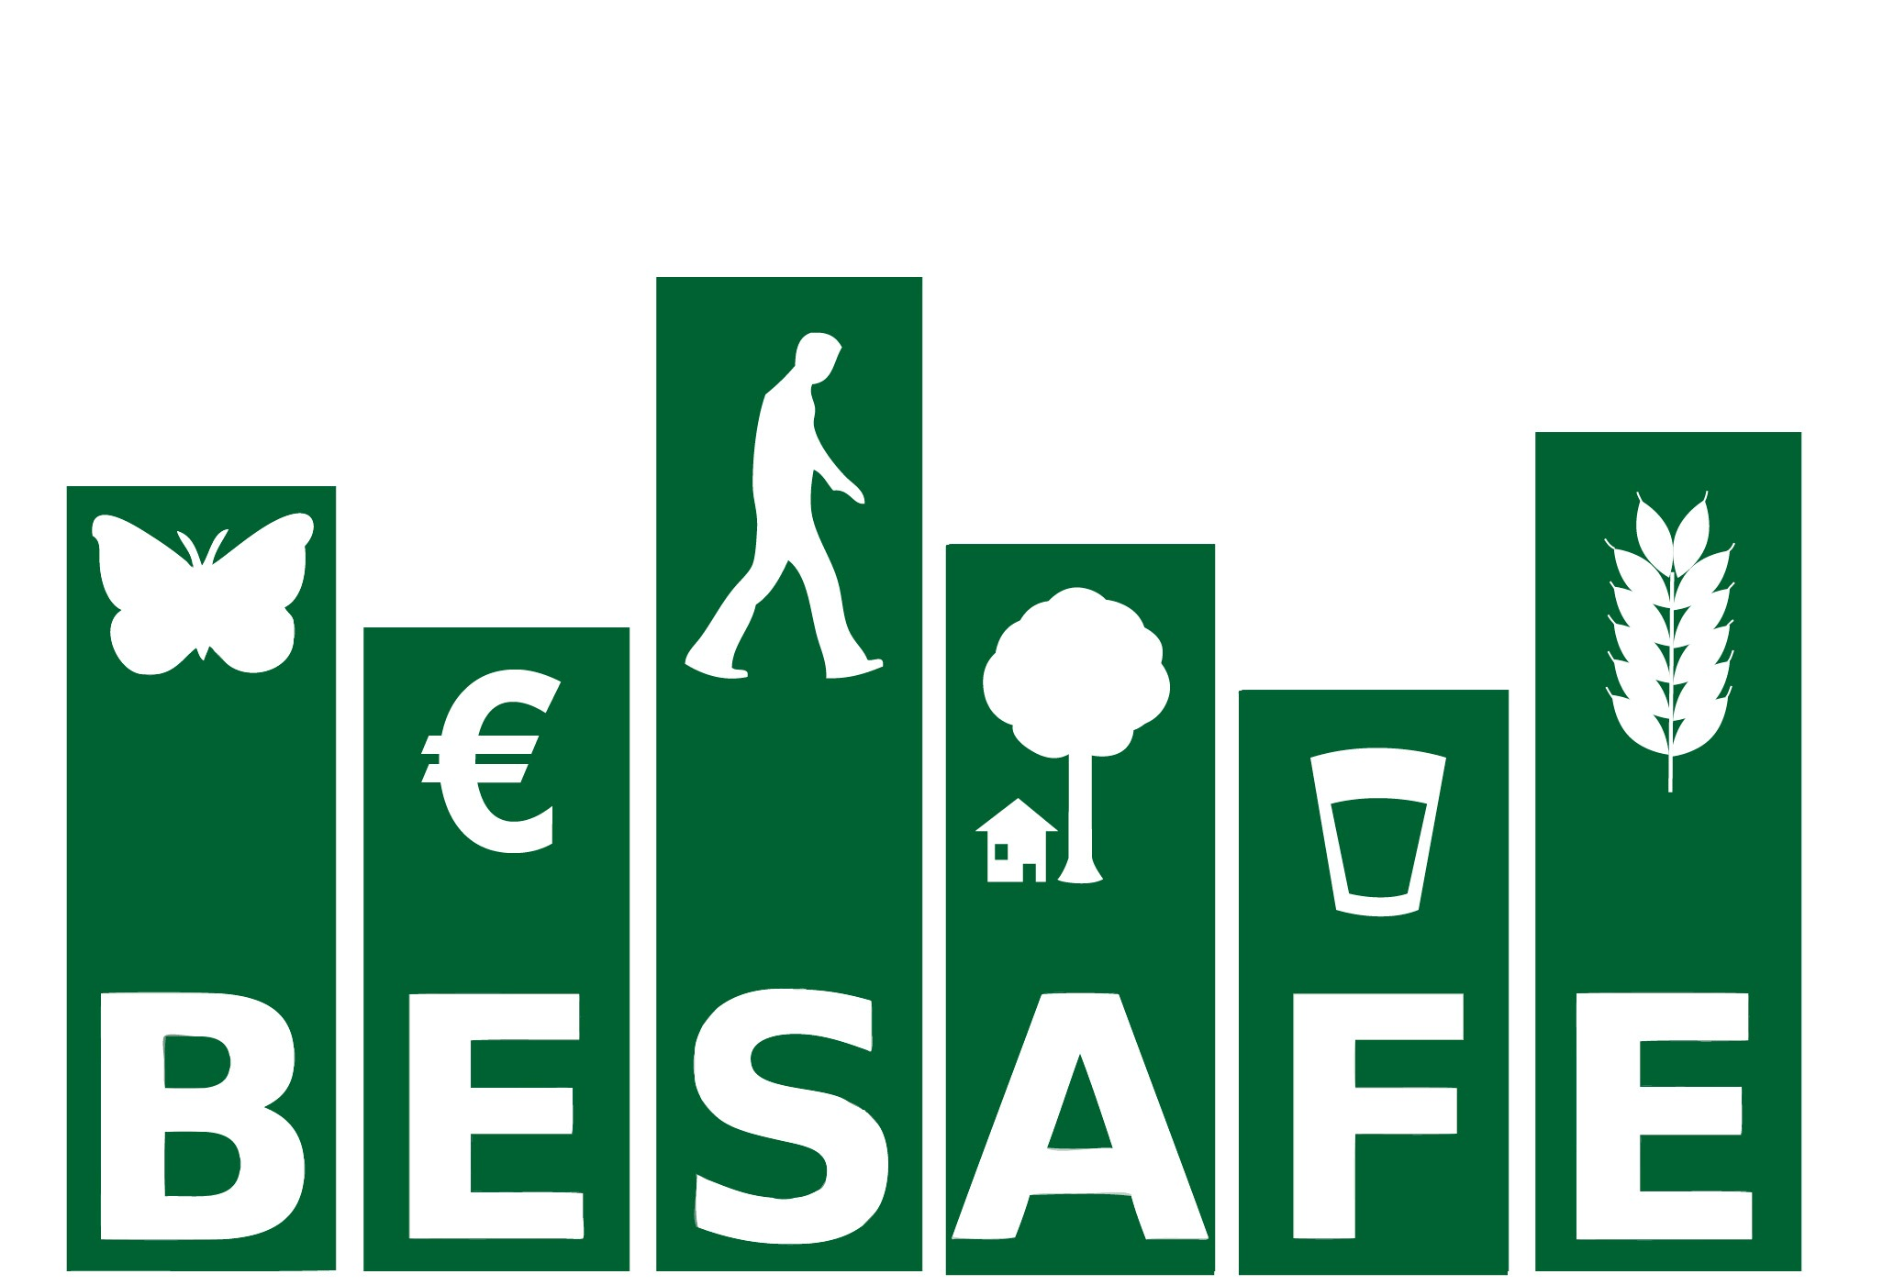

EC Contract Ref: FP7-ENV-2011- 282743

Report of the second stakeholder workshop

13 – 14 May 2014

Park Inn Brussels Midi, Brussels, Belgium

Marion Bogers, Rob Bugter, John Haslett & Rob Tinch

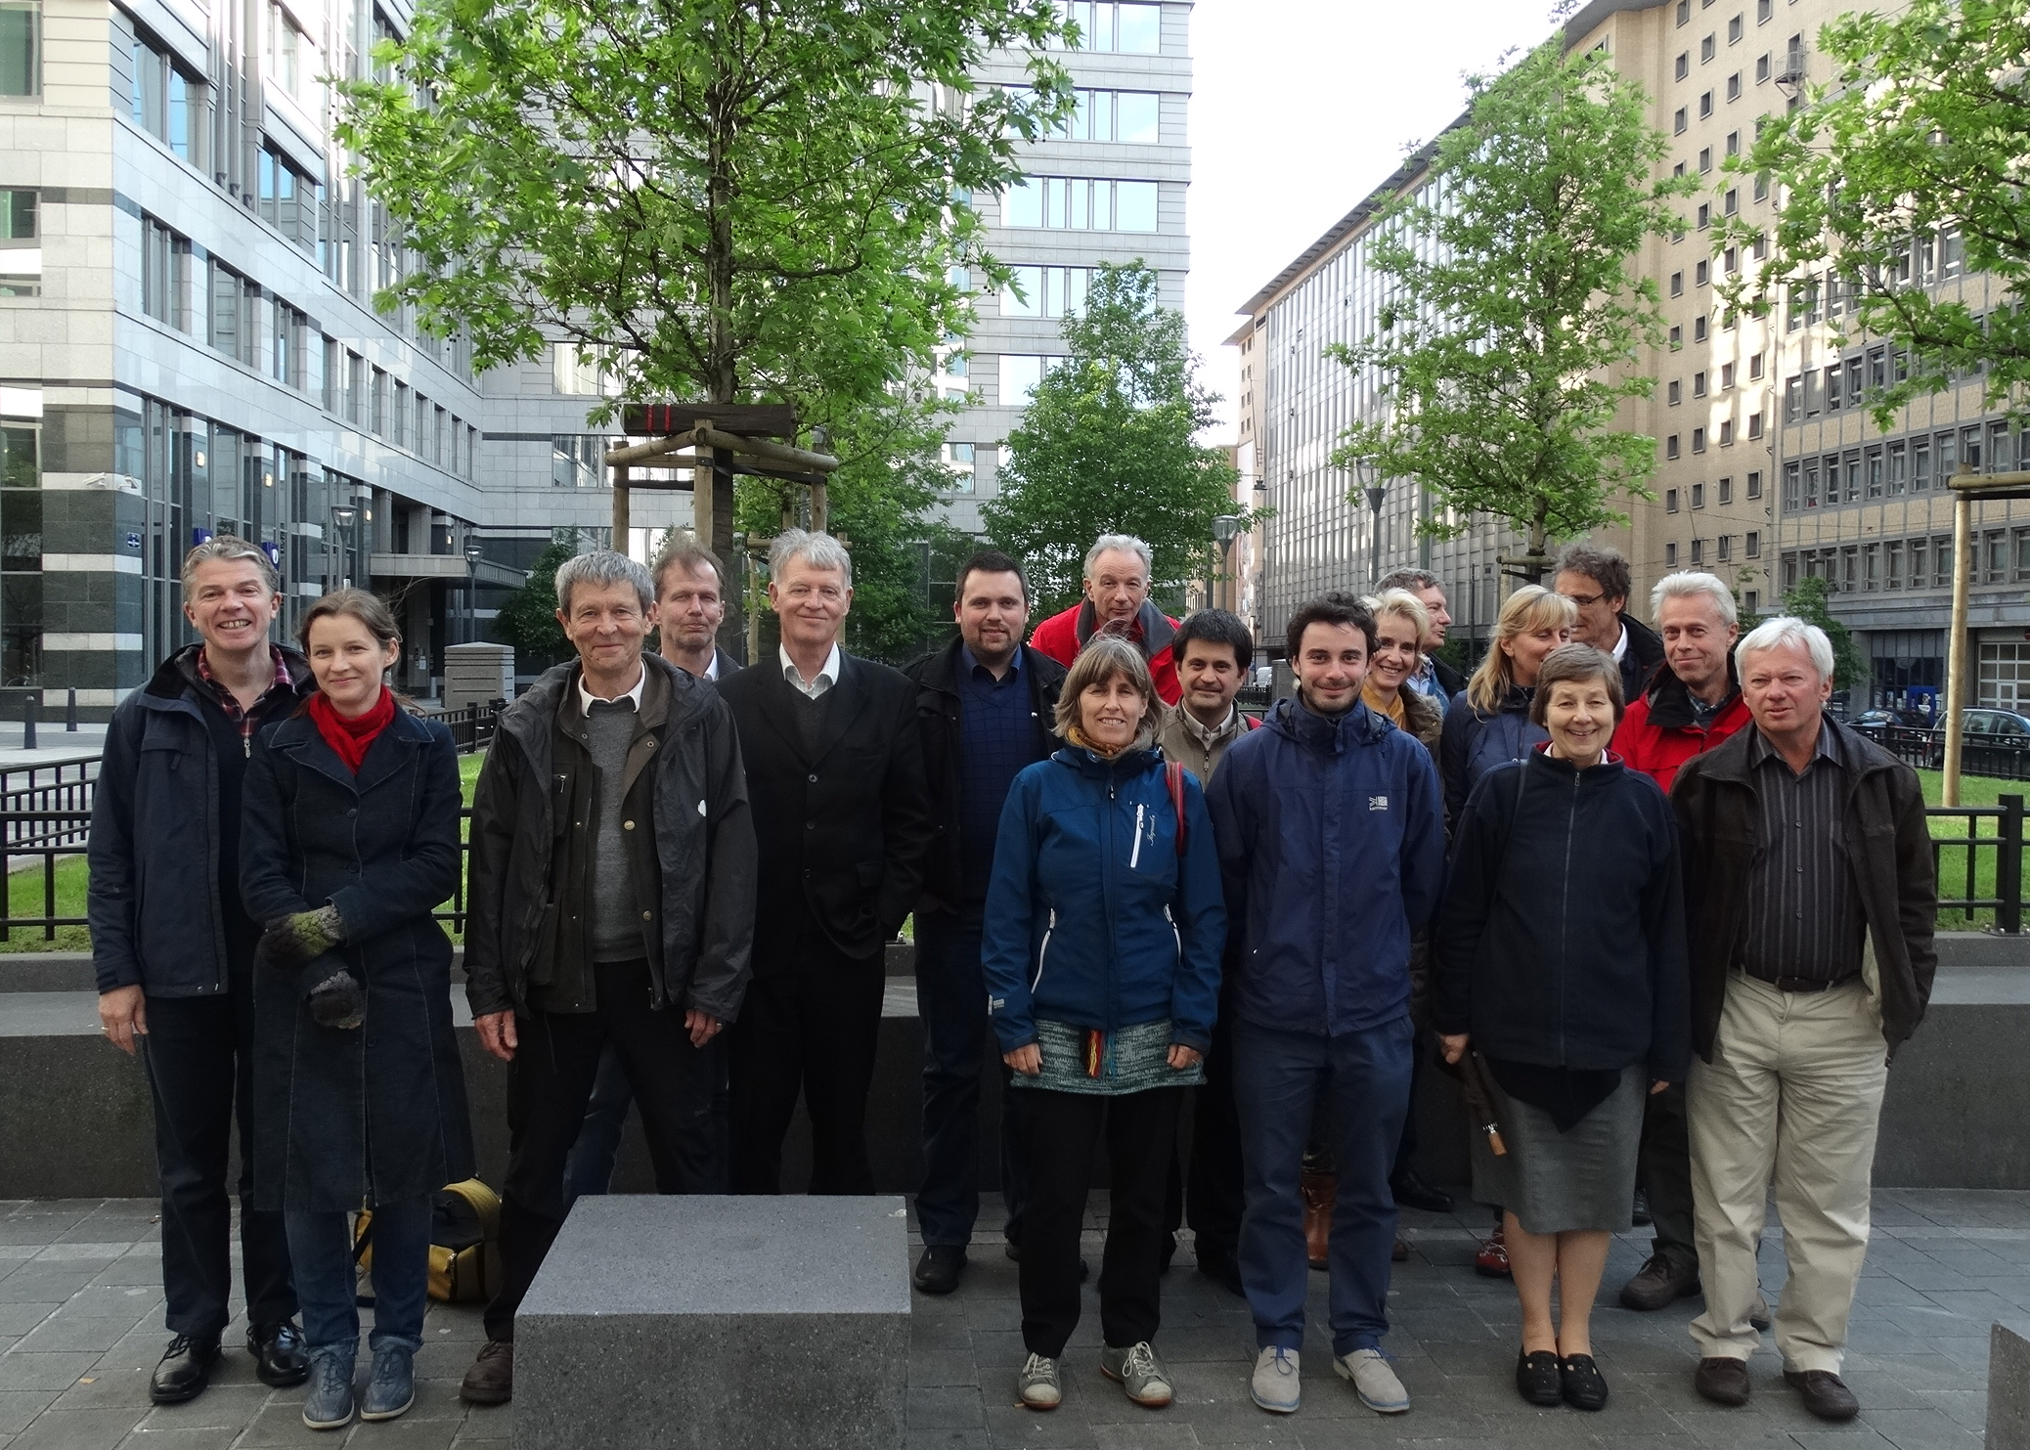
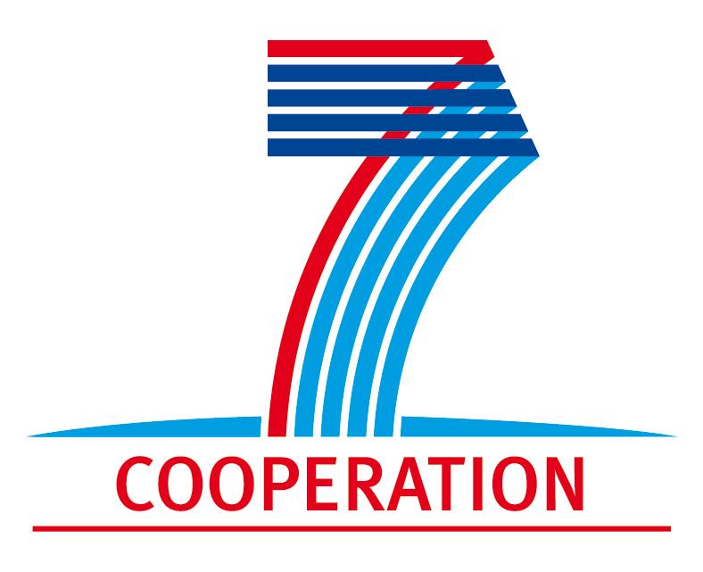
Contents

Aim of the Workshop 3
Workshop report 4
1.1 Stakeholder expectations at the beginning of the workshop 4
1.2 What have we learned so far? 4
1.3 Wrapping up day 1 8
1.4 Introduction on the toolkit and web tool. 8
1.5 Information Briefs 11
1.6 Final plenary and round table discussion 12
1.7 Evaluation of the Workshop 14
1.8 Final remarks 14
Annex 1: List of participants 15
Annex 2: Programme 16

Aim of the Workshop

The objective of this second workshop was to get feedback on the first results of the project and to involve stakeholders in a brainstorm about the requirements for the practical use of and access to our future results.

Workshop report

Stakeholder expectations at the beginning of the workshop
During the introductions, we asked the stakeholders what expectations they had of the workshop, based on the information they received and their knowledge of the project. As specific points, the stakeholders indicated they wanted ‘to learn what the strongest (most effective) arguments are’, ‘to learn about the different types of arguments that can be used by local policy makers’, and ‘to learn about cases in Europe similar to their own ones’. They were also interested in a possible tool/results that can be used by stakeholders, and in learning where, when and how the ecosystem services framework and arguments can contribute to justifying and/or helping conservation policy, decisions and actions.

What have we learned so far?
For the convenience of the stakeholders who did not participate in the first stakeholder workshop, the project’s general aims and structure and the outcome of the first stakeholder workshop were presented as an introduction. This was followed by three rounds of presentations, break out groups (first two rounds only) and plenary discussions. The presentations are available from the policy corner of the BESAFE website.

- “The effectiveness of arguments. Initial results from the case studies”
Pekka Jokinen and Malgorzata Blicharska presented results from our case studies on the implementation of the N2000 network, the National Strategy for Mires and Peatlands in Finland and the Bialowieza forest conflict (for an overview of the case studies please visit www.besafe-project.net) to illustrate the results we are obtaining in our case study work. Our 15 case studies are analysed separately as well as all together. To guarantee consistent collection of the common information on ‘events’ (e.g. policy documents, occasions on which decisions were taken), stakeholders and argumentation used in the case studies , we constructed a database. The effectiveness of arguments (defined as change in behaviour, action due to a particular argument) was also recorded in the database. Examples of the way the database can be used to produce overviews were given. These examples for instance show that different types of arguments are used at different policy stages.

Questions and remarks
Responding to the Finish peat case observation that court decisions were based on ecological values while the interest of locals did not play a role at all, the remark was made that it is only possible for judges to motivate a decision in the terms of the legal framework in question. It is however important to be aware that the actual decision may also have considered other grounds, which do not show in the official documents.

Break out groups
The break out groups were presented with an overview of the database and asked to answer the question “what information in it was most important and relevant for the stakeholders, and why?” They were also asked to indicate what contextual factors would be potentially interesting and important to consider in the analysis.

Specific information on stakeholders in the process was indicated as very relevant: are all of them included, in which way, which stakeholders supports which argument and how effectively is that support. The need was expressed to have results per category, e.g. regional / national, business, NGO, etc.).
Information on the changes in argument use over time was also indicated as being very relevant. Both these features are already part of the BESAFE research plan.

The stakeholders remarked that the right arguments and framing for specific situations should be used, and that a robust framework is needed for consistent interpretation. A question was if it would be possible to give information on the uncertainty of the results as well?

A second question was if it would be useful to group the cases that have similar subjects, in order to reduce complexity and learn from the comparison of similar cases in (slightly) different contexts?

Reflection on the remarks and questions by Pekka Jokinen
We will certainly focus on the changes of arguments in time, this is already in the BESAFE research plan. A grouping of case studies is already in progress. We will also look into the possibility to give information on uncertainty.

- “A comparison of arguments surrounding the Biodiversity Strategy 2020”
Dieter Mortelmans presented an overview of the results of our comparative study of arguments surrounding the Biodiversity Strategy. The aim of the study is to identify commonalities and differences in argumentation at EU and member state levels. For that purpose, argument maps were constructed based on three claims selected at the EU level, resulting in a total of 21 argument maps (3 EU and 18 maps from 6 member States). Arguments per claim were then categorized and compared across countries and between EU and country level. This argument maps analysis provides a good overview of the variety of arguments used for 3 essential claims in the Biodiversity Strategy. Results show that the emphasis is on economy/nature relationship and that there are few political/moral arguments used. The terminology differs depending on document type and there is a wide spread of argument categories (found in all countries). The interpretation of those arguments however varies between countries.

Discussion on the use of argument maps: advantages/disadvantages
The result of the discussion after the presentation was that the argumentation mapping gives a quick overview of complex debates, helps to identify different issues at member state level and can help to match different governance levels. It does however just map the arguments used, and not the underlying political process or resulting actions. It could also be used to study differences of argumentation over time. For the local scale it could be useful for analysing live debates and identifying conflicting stakeholder interests.

Break out groups
The breakout groups were asked to think of specific examples in their area of expertise which could benefit from this research. They were also encourage to think about any other applications or recommendations.

The general impression was that argument mapping can be are useful on several levels, but that it was not clear how it links with local events. The groups indicated that argument maps could be useful to help co-construction of Science-Policy, show which arguments are weak, where the logic in attacking an argument falls down, which arguments you can use to help biodiversity, which ones you can’t and why. Other uses could be to find out which arguments convince different stakeholder types, and to check if assumptions about stakeholder believes are right. Again, the importance of the right framing and right arguments for the right audience and of following the changing of arguments over time was emphasized.

There was confusion about if the mapping tool was part of the BESAFE toolkit. This led to the remarks that we should look at well- established management theory to structure the project frame better, and that the need is not for a toolkit, but for helping people with generalities, to construct their own toolkit.

A second point of confusion was how the argument mapping links to effectiveness. The remarks here were that the question is when did you reach your goal? What were the success criteria from the person making the argument? These might be quite different from what they said were their objectives. For example, we need to be aware of “over-asking” as a negotiation strategy: not getting everything you asked for does not mean the actual goal is not reached; it might have been much lower. This has important implications for how we judge effectiveness!

Reflections: no judgement of their effectiveness is put on the arguments, it is just observed what the differences in use are (i.e. the only indication of effectiveness is the fact the arguments are used, which might indicate the users thought they were potentially effective). The argument maps are created by BESAFE, using an external software tool. The goal was to understand what was going on in the different countries on the Biodiversity Strategy. BESAFE could add a link to the software tool to the tool kit and offer guidance on its use, if this is considered useful for the stakeholders.

- “Evidence for the links between biodiversity and ecosystem services and how ecosystem services are used in argumentation”
Pam Berry presented an overview of a detailed literature review we carried out for 11 specific Ecosystem Services. The review looked at the evidence for relationships between Ecosystem Service Providers (ESPs) and these services and also between ESPs and biotic attributes. We carried out a network analysis looking at connections between service and provider type and attributes. Certain types of ES tend to be linked with certain types of ESPs. However, there are still many gaps in knowledge of the direction and strength of the specific relationships between ES – ESPs – biotic attributes. While the ES valuation literature is extensive, only very few studies explicitly cover the relationships between values – ESBs – ESPs – biodiversity.

She also presented the findings of a Q study on the different views on the relationship between biodiversity and ES, across stakeholders and EU member states. It showed that while policy-makers, researchers and NGOs all have a utilitarian perspective on biodiversity, they do have different perspectives and arguments that they use for the importance of biodiversity and ES.

Plenary discussion
The stakeholders were asked to reflect on the way they could/would use the information on the links between biodiversity and ES, how they would you like it made available, and how they could use knowledge of different stakeholders` views of the arguments.

A first comment was that the nature of the relationship between ES and Biodiversity was not fully covered in the review. The literature shows that there is no single relationship between ES and biodiversity, and indeed that many ES do not necessarily depend on the diversity of life but rather on specific components or functions of ecosystems. Pam Berry explained that indeed we are looking at the components of biodiversity that are important for delivering services, as well as examining evidence for diversity contributing to ES. A second comment was that rare species are not particularly involved in many ES, and could therefore be considered not important, suggesting that the assumption that ES arguments could enhance the protection of rare species may not be justified. This is true for many services – though not, for example, for cultural and touristic services associated with rare species viewing – but it should also be recognized that ecosystem services are often seen as an ‘added value’ concept for biodiversity protection: not a replacement for protection policies grounded on other values (such as rarity and moral obligation to protect) but rather a means of extending protection outside traditional protected areas networks.

Stakeholders felt that the work shown can help conceptually. 5 years ago there was a misunderstanding about biodiversity (considered restricted to conservation). The mapping of ES provision shows biodiversity underpins many things. The review found a lot of evidence, even if not all aspects could be covered. There are however huge gaps, where information is needed. A lot of evidence was found, even if not all aspects could be covered. The network diagrams help identify where evidence is and flag up where evidence may be missing. But the degree of complexity is great. Sometimes the focus is on one main species that provides a service (though generally that species will depend on a healthy ecosystem), but often the interaction among species in providing a function or services is a direct area of investigation and interest. It was also indicated that it would be interesting to explore links between ES and land management as well. The question was asked how detailed work like this fits in with the rest of BESAFE? The stakeholders also indicated the need for good examples: how can the relationships be used for more effective argumentations? The examples are basically there, as for each link in the diagram there is a link to a paper in the literature database.

How can the knowledge on different stakeholder perspectives on arguments for biodiversity and ES be used? Pam Berry explained that this relates to the Q study within WP4, which will also be analysed by country and the views of decision makers will be looked at specifically too. Another question was if we could also look at complexity within groups? It was explained that it is not possible to go down to individual level, but that some contextual information was collected during the study.

Reflections: While we are indeed still reflecting on how we can make the best use of detailed work like this, there is potential for the identified strong links between certain biotic attributes and ES to be used to inform management of ES. They could also be used to identify what components of biodiversity (including species and habitats) are important to ES and therefore need conserving for continued ES delivery. The different stakeholder perspectives on arguments for biodiversity and ES, when fully analysed, could be used to identify arguments that are particularly pertinent to certain types of stakeholders.

Wrapping up day 1
At the end of this first day we reflected on the results that were presented and the main conclusions to be drawn. The importance of BESAFE’s basic idea was again emphasized by the stakeholders: focus on what arguments are useful in which situation. We will look in more detail at the potential usefulness of mapping of arguments in the context of the BESAFE toolkit. . The EU project “Kyoto” (Knowledge Yielding Ontologies for Transition-based Organization) might be interesting to look at in that respect, as this looks at the automatic analysis of the content of texts. The work on the link between ES to biodiversity is interesting, and it will be more interesting to see in which particular cases it can be used in argumentation. It might also be useful to look at how ES relate to the new concept of Nature-Based Solutions, introduced in H2020. “Solutions” sounds better than “service” and “nature” sounds better than “ecosystem”, and the concept could therefore be useful in communication.

Introduction on the toolkit and web tool.
For the next session we asked the stakeholders to reflect on the first set up of the web tool.

Rob Tinch introduced the first draft of the toolkit and web tool to the stakeholders. The toolkit seeks to present outputs of BESAFE in a format suitable for aiding the selection of arguments for different contexts and audiences. It will be available in printed form as well as online. The web tool is intended to be a user-friendly front-end or interface for the toolkit. There are many ways in which these project outputs could be constructed and a key aim of the workshop was to elicit feedback on some initial ideas and guidance for future development.

The toolkit was presented both using a SpicyNodes (www.spicynodes.org) format (see Figure 1) and as a wiki (www.wikispaces.com) (see ). Each format allows users to navigate through the information, with a certain amount of information presented on-screen, and links to more detailed BESAFE ‘briefs’ and to external sources. The SpicyNodes format (selected in part because it was used successfully in the SPIRAL project) provides a visual web of links among different topics and gives limited space for on-screen text – it is designed primarily to guide users through a complex area to the specific information they need, in the form of links to BESAFE briefs, or other sources and projects. The Wikispaces format allows more on-screen information, at the expense of losing the visual overview of links. It was explained that both formats were initial attempts, and in particular that they were incomplete (in terms of final content not being available yet – this will draw heavily on analysis in the final year of the project) and very flexible (we could change most aspects of them, or indeed abandon these ideas and follow different ones).

Initial feedback therefore focused on general reactions to the design, user-friendliness and accessibility of the tools, rather than details of content. Following this, examples of the ‘briefs’ were circulated in printed form, with varying formats, again with a focus more on design than on details of the information content.
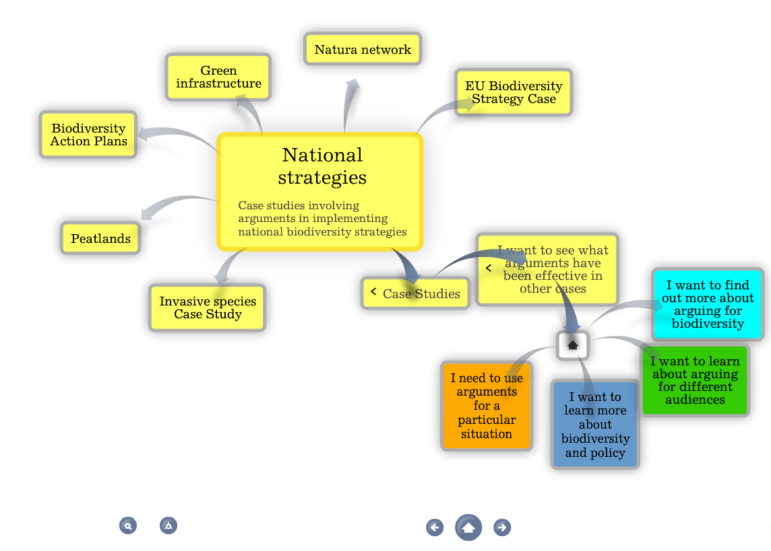
Figure 1: Screenshot from 'Spicynodes' version of toolkit
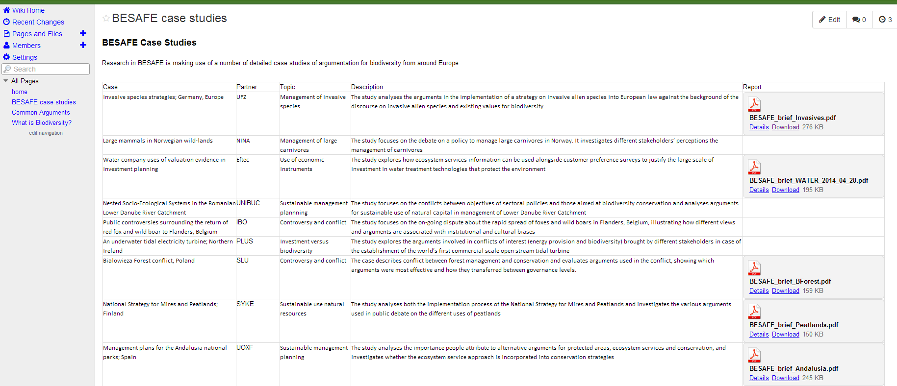

Figure 2: Screenshot from Wikispaces version of toolkit

Comments
One set of comments focused on the user-friendliness of accessing specific information. Although it was recognised that the SpicyNodes framework aimed to provide a logical ‘click-through’ way to guide users to the information they need, it was also suggested that if too many clicks were needed to get through to that information, some people might switch off, or feel lost if it’s not obvious at the start which ‘branch’ they should follow.

In particular, it was suggested that a search engine feature would be very useful. This could take the form of a classic text-search with Boolean logic, and/or a list of check-boxes for topics covered in the toolkit (allowing users to pick out examples matching specific criteria, for example combining successful conservation, agriculture, and water supply). The key questions of interest are likely to be “what has been effective in a particular situation”, and “in which situations has a particular argument been effective”, and it is important that the toolkit should make the answers easily accessible.

There was no general agreement on a single specific format that would be ‘best’, however. Some liked the SpicyNodes format; others commented that this design appealed to ‘young people’ and favoured a more traditional text-based arrangement. In fact, after some discussion, it became generally agreed that different ways of providing the information should be made available.

There were however common themes that should be adopted across all methods, including very clear instructions at the front-end / entry point explaining exactly how the tool structures and treats the information, and how users can find what they need. The front page needs to be less ‘cluttered’ and provide a clear map. The ‘target audience’ and the ‘sector’ are the key elements to stress – the ‘who to contact’ box is not useful at this level.

There was general concern about the longevity of the toolkit and of project results more generally, recognising the fact that BESAFE itself will end with no further funding for keeping the toolkit up-to-date. We explained that options are under discussion; in particular, we are exploring the possibility of integrating BESAFE outputs into the OPERAs/OpenNESS resource hub (currently ‘O-Nest’, but this name is under discussion). Another option is to allow (selected) users, or perhaps a NGO, to edit and maintain the Wiki – taking the toolkit out of the academic research environment into the responsibility of the users. There are of course risks with this approach, not least that the quality control is taken out of project hands, so care would be needed.

It was also suggested that the information could be partly ‘time-proofed’ if it were kept more general, avoiding very specific information that might date more rapidly. To the extent that this is possible it makes sense, although information on case studies and particular policy contexts is clearly quite specific, rules about how to frame arguments for different stakeholder types may be more generalised and ‘timeless’. But languages / jargons change rapidly and some form of periodic updating is probably essential.

The BESAFE focus on successful arguments for conservation was noted and queried: there are also arguments that can be effective against biodiversity. It was suggested that the toolkit might also cover these, in the context of providing information on how to “defeat the opposition”. Although this has not been a primary focus of the research, more specific information can be found in the case studies, and there are already some counter-arguments included in the toolkit, so there is some scope to provide such information.

Stakeholders noted that a lot of the information presented seemed to be targeting scientists, or to be quite academic. A ‘light’ version would be welcomed. Partly this can be addressed by the search functions helping to guide users to bypass extraneous information and move straight to their main interests, and the briefs (presented later) do aim to provide a ‘non-academic’ overview of complex topics.

Information Briefs
As a part of his introductory talk describing progress in the development of the toolkit and web tool, Rob Tinch introduced the concept of Information Briefs. These pieces of writing would provide information to stakeholders as the “endpoint” nodes along the pathways of the web tool, but they would also be made available as a collection in a booklet, forming the basis of the toolkit. This is similar to the design of the presentation of information in the SPIRAL project. Briefs could be written on different subjects, ranging from results of BESAFE case studies to external information relevant to the aims of the Project.

Within the “Learning Workshop” that followed the introduction, hard copies of a number of sample draft briefs were circulated and stakeholders were asked to read and discuss these within three break-out groups. They were asked to report back their main comments in plenary session with following round table discussions. The organisers suggested that stakeholders should address the question “What is useful, what could be improved upon and how?” by considering such issues as subject matter and information content, style, and format of presentation. The stakeholder contributions are summarised below, under three relevant headings, though it is recognised that the content of these sometimes overlaps.

Content of the briefs
Comments from the stakeholders about content distinguished between (i) the subject matter(what should the briefs be about?) and (ii) the information content (what should be included and exclude from the briefs?)

In relation to (i), there was some debate about how much BESAFE results information, such as case study results, should be presented in the briefs in comparison to external, but relevant information from other sources. Stakeholders had an overall view that a balance is essential and that it must be made clear to distinguish exactly which information is which. Also, the stakeholders noted that briefs reporting case studies are in danger of bringing too much information about the story of the case, at the expense of presenting information about arguments. The arguments should be the primary focus of attention, also perhaps including arguments that were observed to fail under particular circumstances. The level of transferability of the case study briefs to other situations needs to be maximised.
Turning to the information content of (ii), the stakeholders identified the inclusion or exclusion of illustrations and diagrams as an important point. The ensuing discussions came to the overall conclusions that diagrams or graphics should be generally included, as this can make the interpretation easier, but there were also warnings that such illustrations take up space, so should only be used where clearly relevant and that the graphics need to be very easy to understand. Stakeholders also discussed whether scientific references to other work should be formally listed at the end of the briefs, but there was no stakeholder consensus of opinion on this issue.

Issues of style and format of presentation
The stakeholders were all of the opinion that the style and format of the briefs were important to overall success in information transfer to wide user audiences. The general conclusion was that several different formats should be used “information for all” as well as more specific formats aimed at different target groups. The stakeholders brought many specific but wide ranging points in the discussions. A cluster of these involved the varying stakeholder opinions that the draft briefs that were circulated were on the one hand too complex and/or too scientific paper-style oriented, but that on the other hand the briefs need to provide a realistic balance between communication skills and science adequacy.

There was a suggestion to write in “press release” style, in which the important information is provided at the start, in short paragraphs, with longer, more explanatory paragraphs later in the text. But it was also pointed out that equally, many readers will also search, in the first instance, in the conclusions section at the end of the brief, and that it is necessary to provide the important information in this part of the document.

Stakeholders also suggested that the length of the briefs should be about 2 pages of text, though the total length could be extended to accommodate diagrams (see above).In addition, stakeholders wished to see a common format of the documents, including, for example, standardised sub-section titles where possible. This would allow the users to scan the different briefs more efficiently.

Other general issues
Stakeholders expressed a need to clarify the relations between the different briefs. This may be interpreted as reflecting comments on subject matter above – it is necessary to make clear what the briefs are reporting, and their relations to each other.

The concern about the information contain after the end of the project was expressed again, particularly in relation to website links that become outdated or are shut down.

Final plenary and round table discussion
The final session confirmed that the participants broadly appreciated the toolkit and found it had potential to be user friendly and useful, after further development and changes.

The section on arguing for different audiences is clearly useful and should be on the front page.

The section “Arguing for biodiversity” is useful for background information, but a different wording was suggested: “Why arguments can work”. The section on case studies, focusing on effectiveness of arguments used, is also useful, though it was suggested that we might consider merging these sections.

The section “I need to use arguments for a particular situation” should be linked to a search engine/topic area to find information on particular arguments/situations; or the search engine could be on a different interface, linking back to the toolkit pages.

The section on “biodiversity and policy” was seen as lower priority: most stakeholder likely to be looking for help with the local situation, how to use arguments with local policy makers. It was suggested that we should focus on core BESAFE topics. It was also suggested that information on EU and national regulations and contexts would be welcome. In fact this rather matches with our intentions: the idea of the non-BESAFE sections is to guide users to outside sources where BESAFE does not directly cover their interests, so that we do not aim to reinvent wheels but also do not leave toolkit users stuck for where to find information they need. It was stressed that we need to make clear what is BESAFE output and what is external.

Locally-specific information would also be welcome, but this is not practical (and could not be kept up to date) – rather, we can suggest strategies for how to find this information.

The section “I want to find out who to contact” should be deleted from the front – contact suggestions can come at the end of particular branches, along with links to further information.

On style, the information should be kept simple and easy to find. The information will not be complete – we only have a limited number of case studies – but we can provide new ideas, knowledge, illustrate and stimulate to help users draw on the toolkit for their own work. It was agreed that there should be no references in the briefs – academic details can be left to the full reports, linked to from the briefs/web tool so that any users interested in such information can find it. Different formats were proposed, for example following the ”Findings for All” concept used in BIOMOT - less ‘heavy’ than a policy brief. Again, multiple methods could be useful, allowing different users to find the style they most appreciate.

The importance of user-friendliness was again stressed: key suggestions were clear information at the front-end, guidance for users, headline data providing overview of main findings as an introduction to different topic areas, and searchable lists of keywords and topics guiding users to the information they most need.

Evaluation of the Workshop
Reactions to the workshop were positive. The stakeholders said they’d liked the fact that we genuinely listened, reacted and even changed the agenda/breakout in response to their comments – we weren’t just there to present and defend our work: ‘good to take time to think about these issues and to hear from different perspectives’, ‘the workshop had the right length and was rich in content’, ‘I feel nourished and rich’, ‘it was nice to meet other stakeholders and get informed on the research’. ‘Happy there was no defensiveness from the researchers on the comments: this was refreshing’ .’ I could use the toolkit with a lot of data and projects’.

Points for improvement
- Informing stakeholders before the meeting
Send information on the dates of the workshop at an early stage. ‘Sometimes assumptions were made about stakeholders’ knowledge’. But also: ‘I visited the website before the meeting. 10 minutes was enough to get an idea’. More targeted information should be distributed before the meeting for participants to prepare themselves: brief us before the start. What are the purposes, expected end results. Road testing could also be done before the workshop. But: also provide a brief with just enough to read in the airplane/train.

- Role of stakeholders
Use the stakeholders better, who have the knowledge about the arguments, because we use the arguments and know when (in which context) an argument can be effective or not. Therefore use the time with them better, not too many presentations (i.e. provide the information beforehand). Next time we should have more practical exercises in groups.
BESAFE should get more background information on the invited stakeholders before the meeting to be able to use their input better, and also provide this information to the other stakeholders.
Provide more structure and provide a written brief before each breakout.

Final remarks
As the BESAFE project approaches its concluding phase, we will continue to ask for the active involvement, and indeed hope to increase stakeholders´ participation in the development of the web tool. Most participants of the first workshop and all of this one expressed interest in helping us with that. After a first working version is developed later this year, we will therefore ask them to test it and give their feedback. Participants were thanked for their contributions.

Annex 1: List of participants
Surname | First name | Institution
Owen | Roger | SEPA
Radoslav | Stanchev | Ministry of Environment, Bulgaria
Eriksson | Liselott | Nacka University
Costello | Brendan | RSPB
Smithers | Richard | AEA
Wiersema | Menko | Province of Zuid-Holland, NL
Hubert | Claire | MEDDE
Holland | Alan | Lancaster University
Heistek | Jolanda | Triple-E, NL
Sandström | Ulf | County Administrative Board Örebro
Løken | Øivind | Norwegian farmers (NGO)
DeGroot | Wouter | BIOMOT (Radboud University Nijmegen)
Popa | Florin | BIOMOT (Leuven University)
Partners
Blicharska | Malgorzata | SLU
Tinch | Rob | EFTEC
Berry | Pam | ECI
Bogers | Marion | Alterra
Bugter | Rob | Alterra
Van Herzele | Ann | INBO
Mortelmans | Dieter | INBO
Grudova | Margarita | Pensoft Publishers Ltd
Haslet | John | PLUS

Annex 2: Programme

Tuesday 13 May
13.00 Welcome and opening
13.15 Introductions and expectations
13.45 - 17.00 What have we learned so far?
- 13.45 Introduction: Rob Bugter (BESAFE coordinator)
- Block 1: 14.00 – 15.00 The effectiveness of arguments. Initial results from the case studies: Pekka Jokinen
15.00 Tea break
- Block2: 15.30 – 16.30 A comparison of arguments surrounding the Biodiversity Strategy 2020: Dieter Mortelmans
- Block3: 16.30 – 17.30 Evidence for the links between biodiversity and ecosystem services and how ecosystem services are used in argumentation: Pam Berry
17.30 – 18.00 Reflection on today’s discussions and introduction to tomorrows learning workshop
19.30 Dinner at La manufacture, 12 O L V van Vaakstraat, Brussels

Wednesday 14 May

9.00 Introduction on the toolkit and web tool. Rob Tinch
9.30 – 12.00 Learning workshop
10.30 – 11.00 Coffee break
12.00 – 12.30 Final plenary and round table discussion on the main issues and outcomes
12.30 Closure and lunch

I.e. arguments based on agreements in the political domain, which can be seen as combining legal and social, ‘democratic’ obligations
These interpretation differences could at a later stage possibly be linked to context factors

